Disclaimer
In UNLV, there has been a problem of standardizing Code Execution and IDE Setup. Because of different machines (Windows/Mac), there isn’t a single guide.

Some students have issued complaints about IDE Setup and how it takes away from learning how to actually code.

This tool attempts to remedy that issue by creating a plug and play IDE so that students can focus on actually coding instead of IDE Setup

Warning
If students are to continue on their professional development journey, at some point they would need to learn how to set up an IDE. Different software teams use different setups.

While for the purposes of this course, this IDE would work, students should also explore on their own regarding IDE setup.

Solution
Docker solves the programming issue, “but it works on my machine”. This is when code runs perfectly on one machine but not on another. Docker uses the same setup and solves this problem. With a Docker application, the same program runs on every machine seamlessly.

You will be able to run your code simply by downloading Docker and running the IDE program.

Additional Resources
These are additional information if you want to learn more about Docker, but it is not necessary. The purpose of this course is to learn programming fundamentals and not learn Docker! You can simply download Docker to your respective machine and run the program! Happy Coding!

Docker in 100 Seconds
The Only Docker Tutorial You Need to Get Started
Containerizing CS50

AI Usage
Please adhere to the guidelines and terms outlined in the CS 135 course. Here is the link to the chatbot resource.

https://cs50.ai
Setup Instructions

Step 1: Download the Application

Download Docker Desktop: https://www.docker.com/

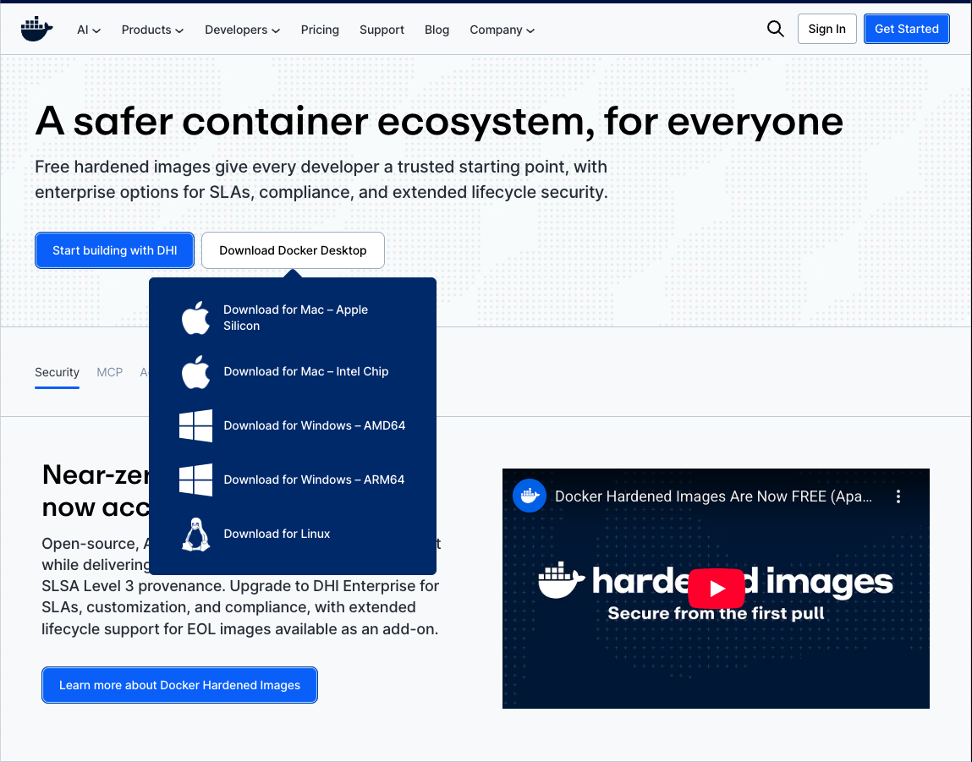

Step 2: Access the Application

There is no need to be logged in!

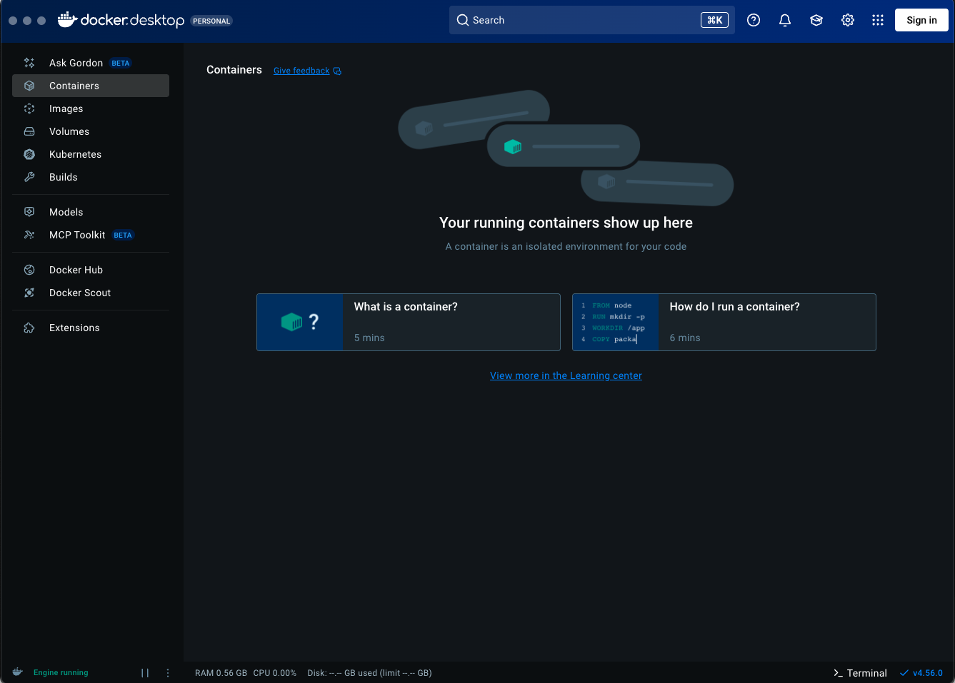

Step 3: Access the Terminal

Access the terminal and paste this command:
docker run -it -p 127.0.0.1:8080:8080 -v cs135_data:/home/coder/CS135 seancnc/unlv-cs-ide
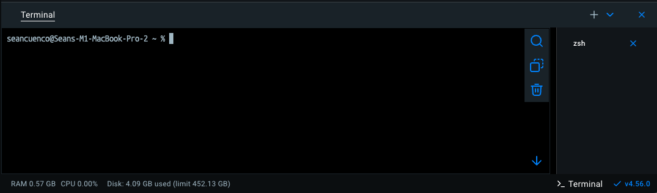

Step 4: Access the Container

Click on containers and then on the Port 8080:8080.

This should lead you to the IDE (Integrated Development Environment)

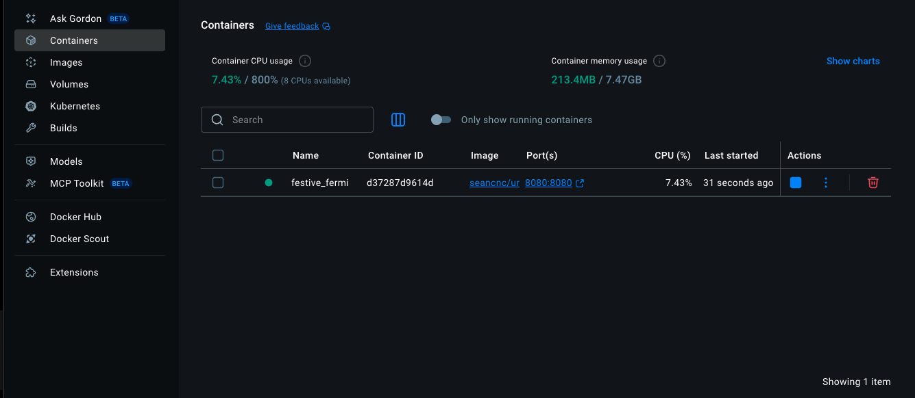

Step 5: Access the IDE

The folder is presaved. It should save files as you create and delete them on your browser IDE.

Code should compile with the play button or the terminal using linux commands.

Save the files into your computer for submission to CodeGrade as it does not get saved on your local files only in itself.

Happy Coding!

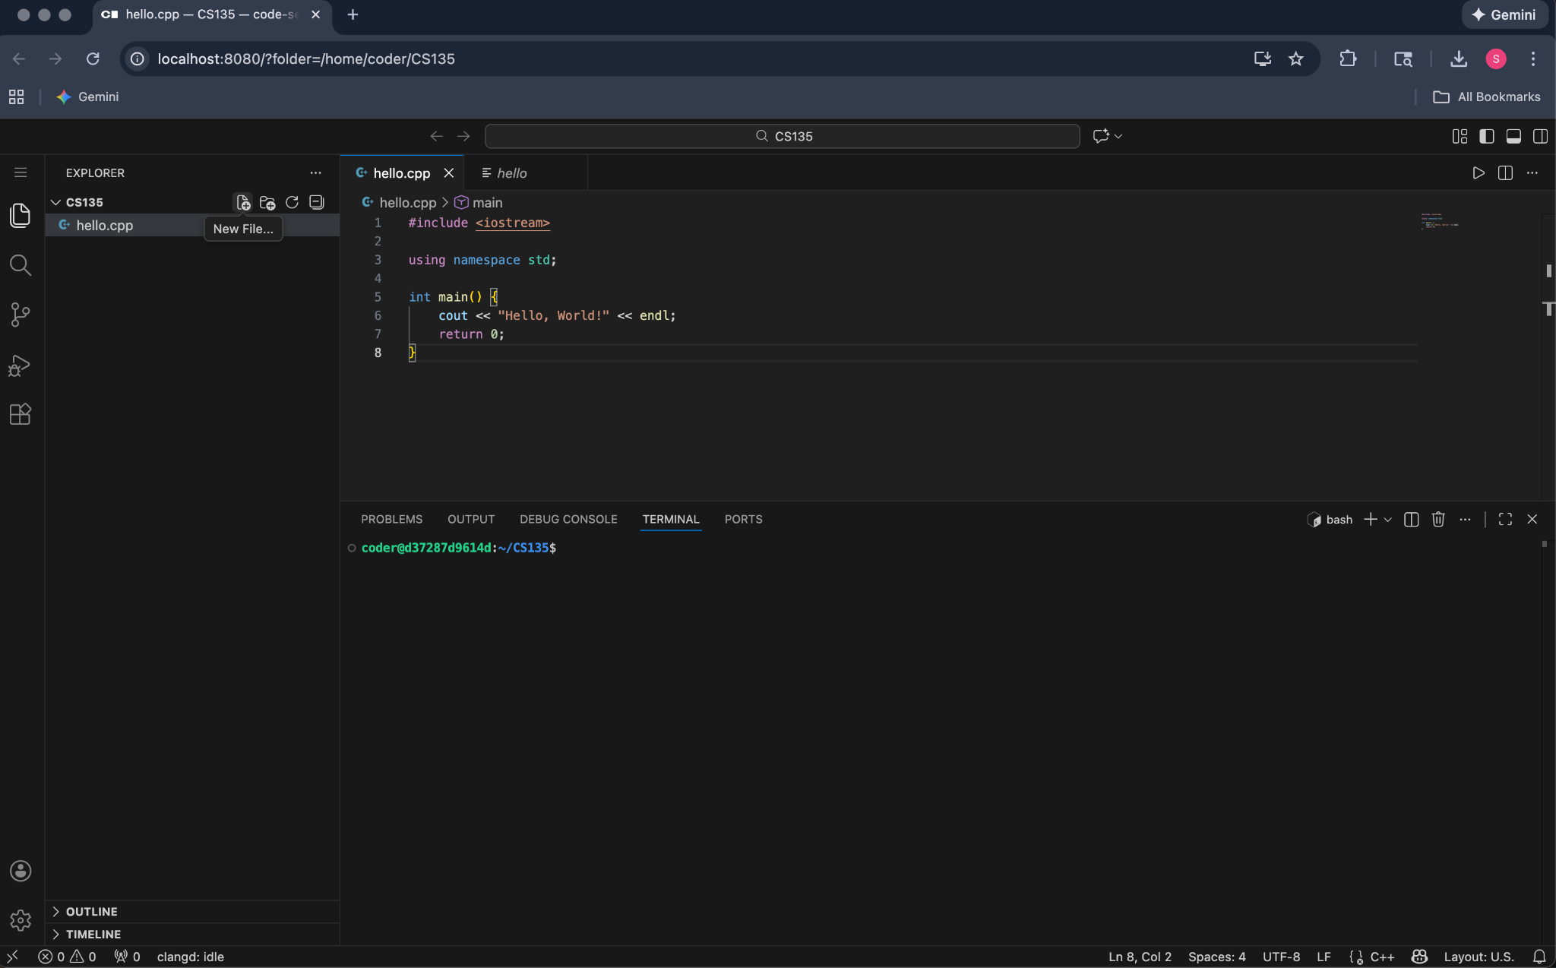

Step 6: Closing

You can also close or start the container by this button to save resources.

Check your files and they should be saved.

